Core skill - Complete the multiplication grid and practise the ones you are finding difficult.
Activity 1
LO: To recall multiplication and division facts for multiplication tables up to 12 × 12.

Depth task – Read what Teddy says. Then share your reasoning with a family member. Is he correct, or incorrect?  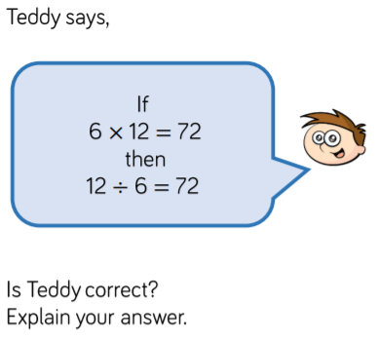 | Solve the calculations to find out which is the odd one odd.  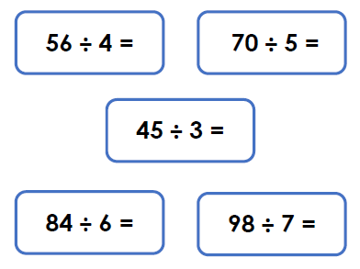

Greater Depth - Can you solve the missing numbers? You might need to use your knowledge of the inverse operation for multiplication, which is to division.
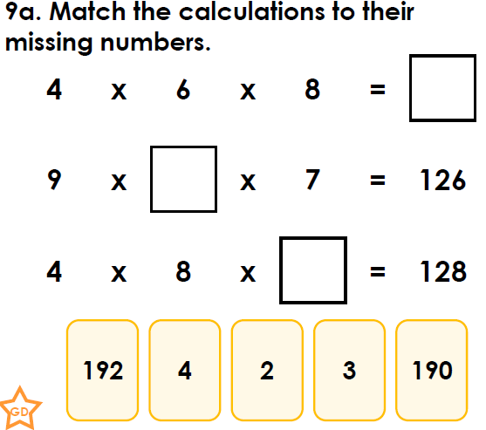

Activity 2
LO: To recall multiplication and division facts for multiplication tables up to 12 × 12.
Core skill - Complete the missing number lines using your multiplication knowledge.

1. ___, 21, ___, 27, 30, ___, 36, 39,___, ___,
2. 24, 30, ___, 42, 48 , ___, 60, ___ , 72,
3. 27, ___, 45, 54, ___, 72 , 81, ___,
4. 21, 28, ___, 42, 49, 56, ___, 70, ___
5. 12, ___, 20, 24, ___, 32, 36, ___, ___
6. ___, 16, ___, 32, 40, 48, ___, 64, 72

Depth task – Match the calculation below to their missing numbers or symbol.
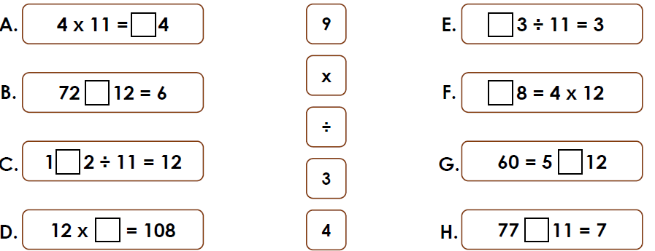

Greater Depth - Write out the 4 and 6 times tables and think about where you need to place the multiples into the Venn diagram.
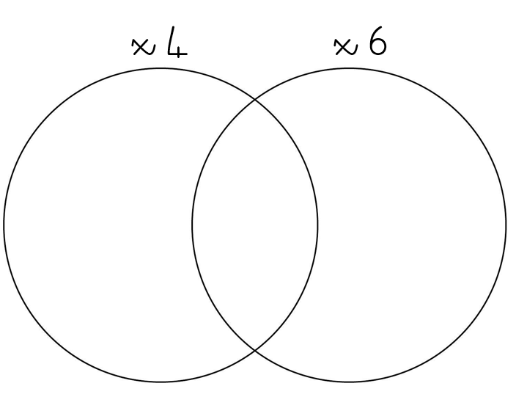

Activity 3
LO: To recognise and use factor pairs and commutativity in mental calculations.
Core skill - A factor is a whole number that multiplies by another number to make a product e.g. 3 × 5 = 15, factor × factor = product. The factor pairs for 15 are 1 and 15, 3 and 5.
Write the missing factors in the empty boxes.
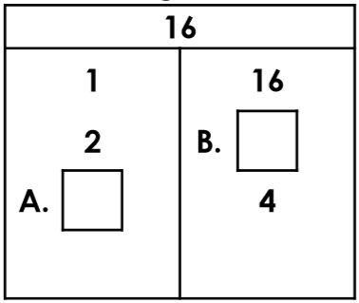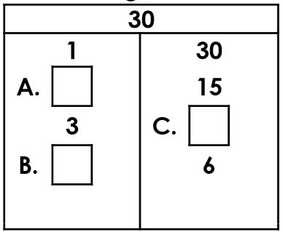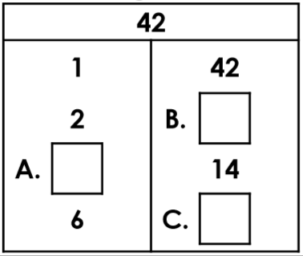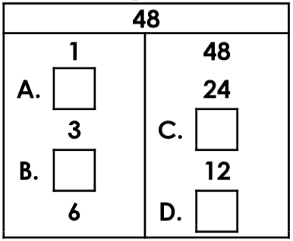
Depth task - Look at the factor pairs for 36 and 54. Can you circle the correct factor pairs? Use your multiplication knowledge to help you.
36 |  | 54

Is this statement below correct? Explain your answer by writing out all the factor pairs for 28 and 24.
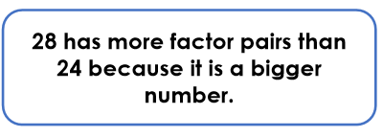

Greater Depth - Aleena is planting seeds in her garden in rows. The total number of seeds has these two factors and is less than 60.
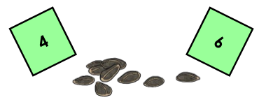

How many seeds might she have? Can you find three possible answers?
Core skill – Read the example below to explain how to use the grid method.
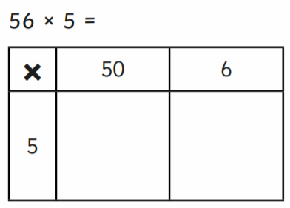
250
- Partition the largest number in to tens and ones. 56=50+6
- Then multiply the tens 5x50=250.
- Then multiply the ones 5x6=30
- Then add your answers together 250+30=280.
30
Complete the following multiplcations using the grid method.
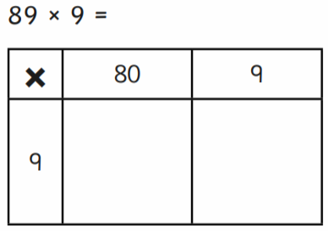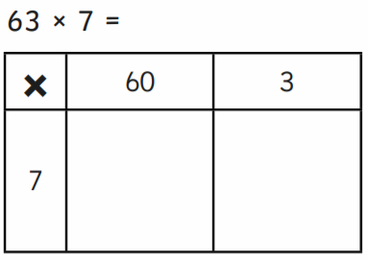

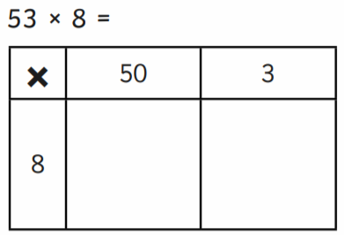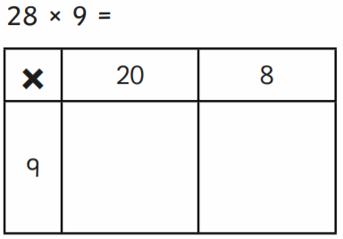
Activity 4
LO: To multiply two-digit by a one-digit number using formal written layout.

Depth Task  Imaan cycles 32 miles a day for 7 days and Steve cycles 36 miles a day for 5 days. Who cycled the furthest?  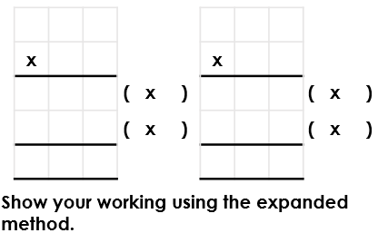 | Find the missing numbers to complete the calculation.  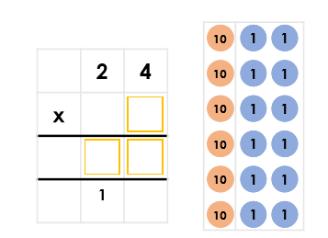
Greater Depth
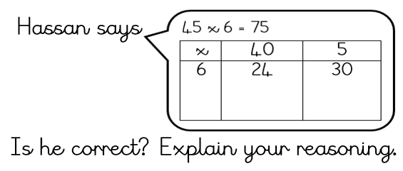

Activity 5
Core skill - Complete the following multiplcations using the grid method. Remember to partition the number into hundreds, tens and ones.
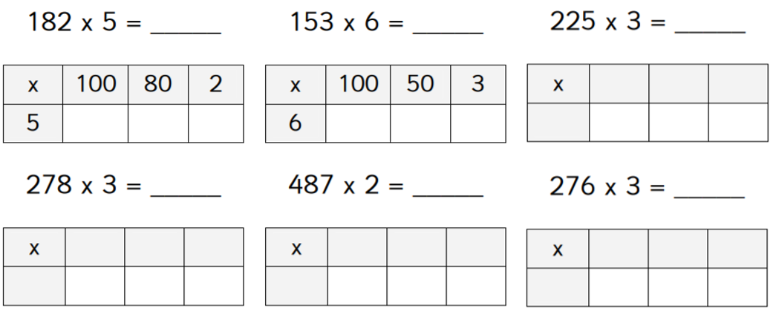
LO: To multiply three-digit numbers by a one-digit number using formal written layout.
Depth task
Prove it. Show your working out in your book and write a sentence to explain your reasoning.
If I multiply 654 by 8 it is the same as multiplying 654 by 4 and doubling it.
Jack says
654 x 8 = 654 x 4 =
answer x 2 =

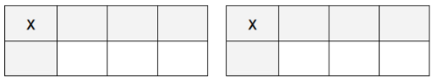
Greater depth  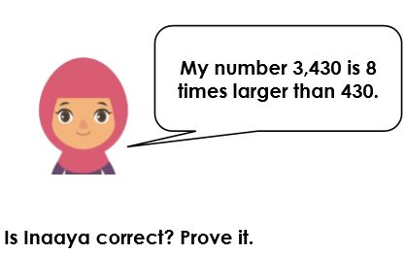 | Match the numbers which have an answer of 3,456

Answers
Activity 1
Core skill
Complete the multiplication grid and practise the ones you are finding difficult.
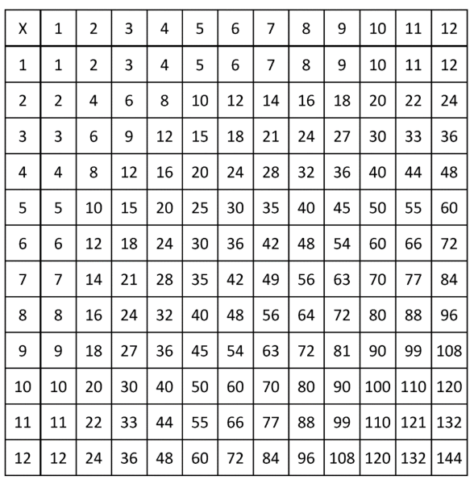

Depth task  Teddy is not correct because 12 ÷ 6 = 2  He should have written 72 ÷ 6 = 12 or 72 ÷ 12 = 6 | 45÷3=15 is the odd one out because it has the answers of 15. The other calculations have the answer of 14.  56÷4=14  70÷5=14  45÷3=15  84÷6=14  98÷7=14
Greater Depth | - 4 x 6 x 8 = 192  - 9 x 2 x 7 = 126  - 4 x 8 x 4 = 128

Activity 2
LO: To recall multiplication and division facts for multiplication tables up to 12 × 12
Core skill
Complete the missing number lines using your multiplication knowledge. Write the answers in your book.

1. 18, 21, 24 , 27, 30, 33, 36, 39, 42, 45,
2. 24, 30, 36, 42, 48 , 54, 60, 66 , 72,
3. 27, 36, 45, 54, 63, 72 , 81, 90,
4. 21, 28, 35, 42, 49, 56, 63, 70, 77
5. 12, 16, 20, 24, 28, 32, 36, 40, 44
6. 8, 16, 24, 32, 40, 48, 56, 64, 72

Depth task
A = 4, B = ÷, C = 3, D = 9, E = 3, F = 4, G = x, H = ÷

Greater Depth - Always, sometimes, never. Multiples of 4 are also multiples of 6. Complete the Venn diagram to show your understanding.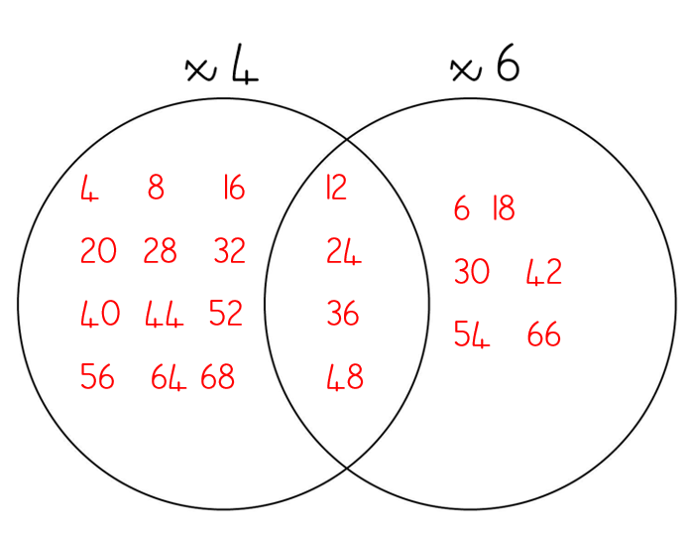

Activity 3
LO: To recognise and use factor pairs and commutativity in mental calculations.
Core skill - A factor is a whole number that multiplies by another number to make a product e.g. 3 × 5 = 15, factor × factor = product The factor pairs for 15 are 1 and 15, 3 and 5,
Write the missing factors for the following.
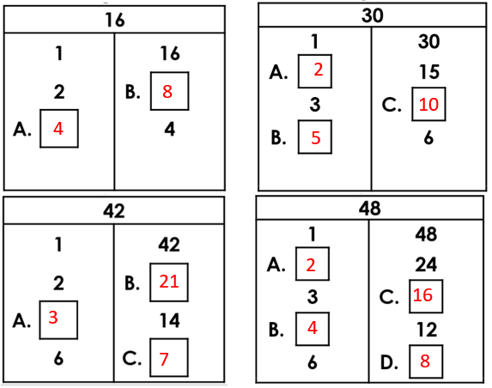
Depth task
Rewrite all the factor pairs of the following numbers,
36 |  | 54

2. Is this statement below correct?
28 1 x 28, 2 x 24, 4 x 7 = 3 factor pairs
24 1 x 24, 2 x 12, 3 x 8, 4 x 6 = 4 factor pairs
False. 28 has three factor pairs and 24 has four. Just because a number is larger, it does not mean it has more factor pairs.

Explain your answer by writing out all the factor pairs for each number.
Greater Depth
Aleena is planting seeds in her garden in rows. The total number of seeds has these two factors and is less than 60.
12, 24, 36, 48 – all of these numbers have factors with 4 and 6.

How many seeds might she have?
Find three possible answers.

Activity 4
LO: To multiply two-digit by a one-digit number using formal written layout.
Core skill -
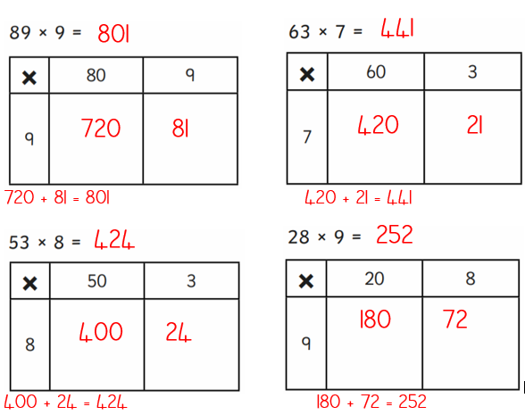

Depth Task  Tony cycles 32 miles a day for 7 days and Steve cycles 36 miles a day for 5 days. Who cycled the furthest?  Tony cycled 224 miles while Steve only cycled 180 miles. Tony cycled the furthest. | Find the missing numbers to complete the calculation.  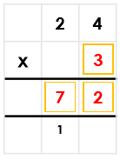
Greater Depth
Hassan is incorrect. He has shown the answer for 6 x 4 instead of 6 x 40.
6 x 40 is 10 times bigger than 6 x 4. His working out should look like this:
x | 40 | 5
6 | 240 | 30
240 + 30 = 270.
The answer should be 270.

Activity 5
Core skill
Complete the following in your book.
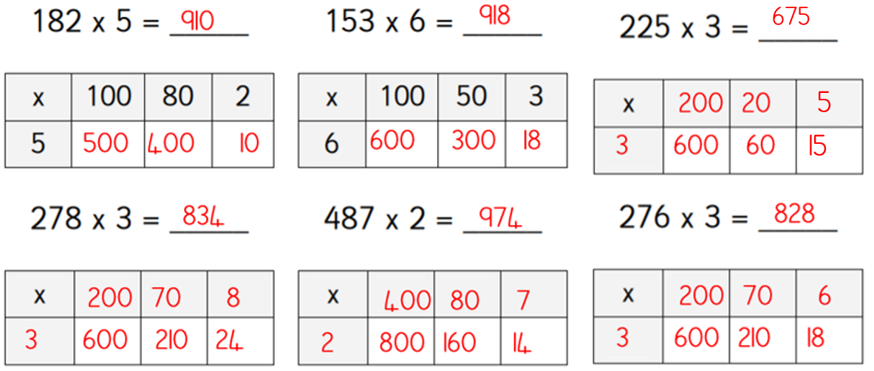
Depth task - Prove it. Show your working out in your book and write a sentence to explain your reasoning.
If I multiply 654 by 8 it is the same as multiplying 654 by 4 and doubling it.
Jack says
654 x 8 = 654 x 4 =
answer x 2 =
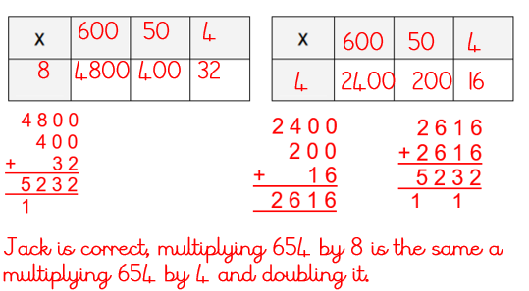

Greater depth  No she is incorrect because  430 x 8 = 3440. | Match the numbers which have an answer of 3,456  The only 2 answers are:  864 x 4 = 3456  432 x 8= 3456  The numbers 3, 6, 735 and 908 cannot be used.

