Week beginning 11th May – Science – Light
Activity 1 – Make your own Kaleidoscope
What is a kaleidoscope?
Kaleidoscopes look a little bit like a small telescope that you can hold in your hands. One end has a hole you can look into. The other end has translucent paper or other material that lets light in.
Inside the kaleidoscope, there are mirrors arranged in a circle, as well as a variety of colourful objects, like beads, pebbles or small pieces of glass, that are free to move around. As you look through the viewer and rotate the outside of the kaleidoscope, the mirrors reflect the movement of the small objects to create fascinating visual images that change with each movement.
Wow! Look at the amazing images that a Kaleidoscope can make.
You may already have one of these toys at home but if you don’t you can make one!

Follow the instructions below:
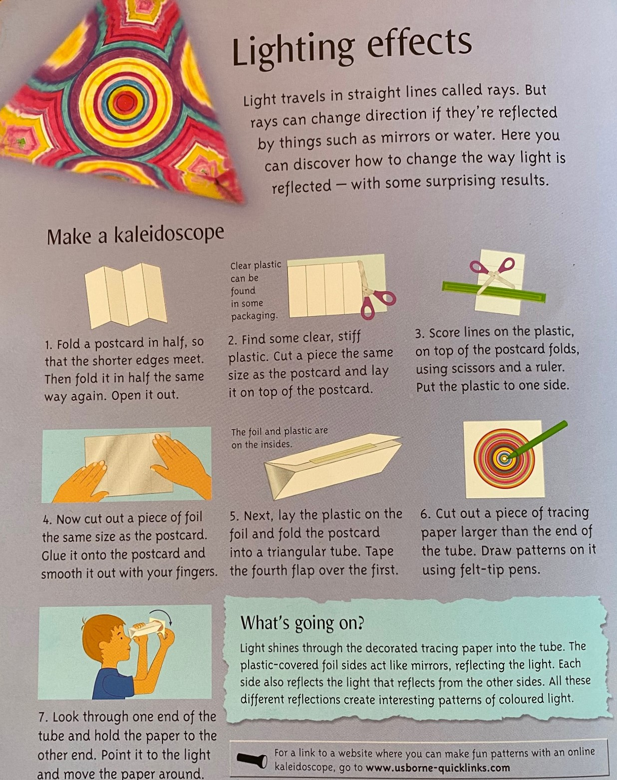
Or have a go at following this video guide to make one:
https://www.bbc.co.uk/cbbc/thingstodo/bp-konnies-kaleidoscope-make?collection=cbbc-top-picks-today
Or you could have lots of fun trying and experimenting with this online version
https://permadi.com/java/spaint/spaint.html
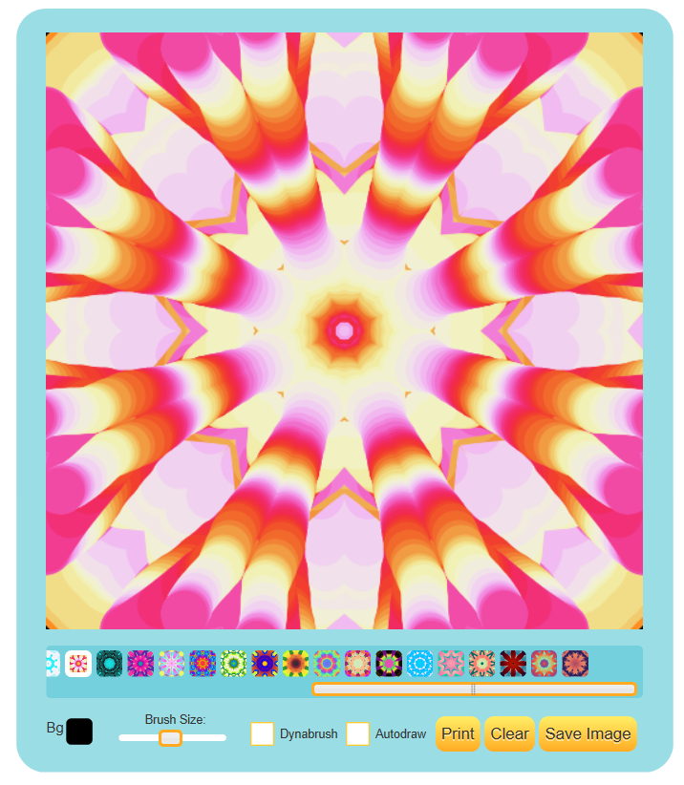

Activity 2 – Surprise spinners
Surprise spinner helps you to investigate what happens when three colours are spun around and mixed – you could further this investigation by repeating it but using three different colours and see if the result is the same. Why not even try all the colours in the rainbow?
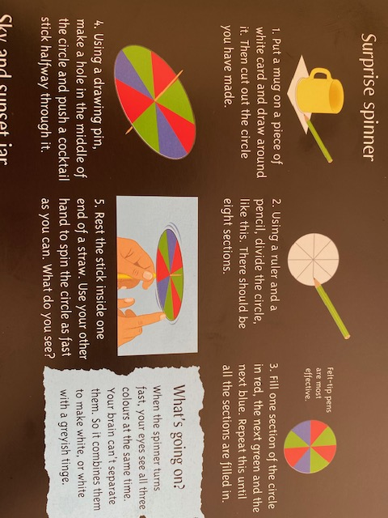
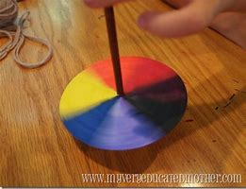
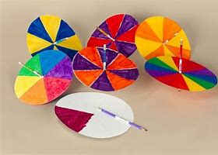

Watch how to make a colour wheel
https://watchkin.com/2fa5edb62b
Extra Activity – Fireworks in a glass
Create your own mini 'explosions' in a glass. Once you've mastered it, why not change the temperature of the water and see what difference this makes?
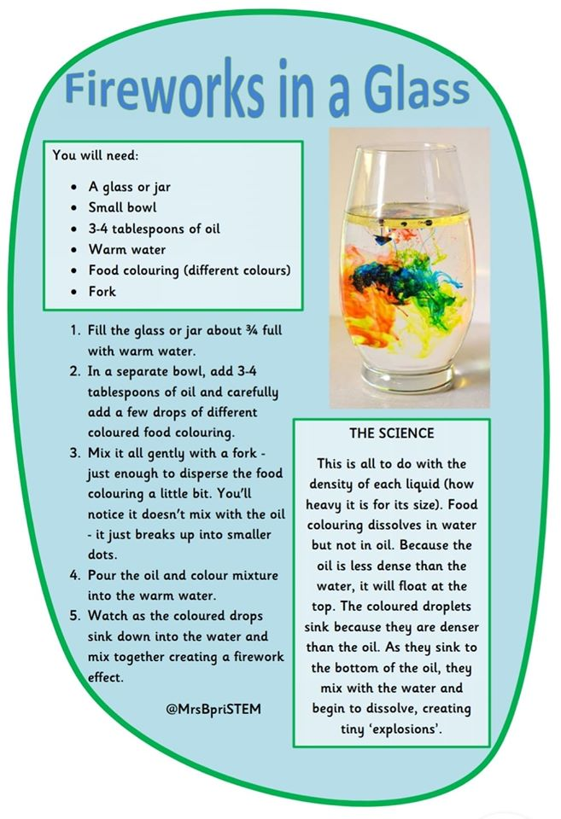

We look forward to seeing your amazing experiments

Miss Garnett

More links for experiments to do at home
Here are some more web links of experiments that you can do at home. Remember to always ask permission from an adult before doing any scientific investigation.
Coke and Mentos
https://watchkin.com/29f1ba9122

Egg experiment
https://watchkin.com/e4a9a9f6db

